Condobolin High School
Mobile Phone Policy

Date Implemented: Term 2 2021
Review Date: Term 2 2022

Objectives/ Policy Statement
Condobolin High School recognises the dramatic rate of change in technology in society and the enormous range of applications available. Proper use of this technology will benefit students and the school alike. This policy aims at addressing the issues of appropriate and proper use of electronic devices at Condobolin High School.
To foster a culture of appropriate use of technology and an instructional climate that is free from interruption and distraction, we require all parents and carers to agree to support the school in the appropriate use of technology and electronic devices, in particular mobile phones.
Additionally, mobile phones are sometimes viewed as enhancing security for students travelling to and from schools or institutes. It is the responsibility of students who bring mobile phones to school to use them appropriately.
Audience
The intended audience/s of this policy includes all members of the Condobolin High School community – students, parents/ carers, teachers and school executive.
Context
The priority at this school is to provide a safe and peaceful learning environment where students can focus on learning. All students at Condobolin High School will comply with the Phone GO/ NO system, implemented in Term 2 2021. Additionally, student use of mobile phones must comply with the Australian TELECOMMUNICATIONS ACT 1997.
It must be noted that: emergency phone calls between students and parents/carers are available through the school administration office (ph 68952333) and should only be made through this avenue to ensure staff are informed and can support students during an emergency.

Appropriate Use of Mobile Phones
Appropriate use of Mobile Phones will be directed by staff members using the Phone GO/ NO system.
The Phone GO/NO system will be introduced to prevent mobile phones from distracting from learning.
This simple system follows 3 steps:
1. Teachers display Phone GO or NO signage at the start of each lesson.
2. If a teacher sees a student with their phone during a Phone NO lesson, they are given one verbal warning.
3. If the teacher sees the phone again the student is expected to put it in the confiscation basket/ on the teacher’s desk in the classroom as directed by the teacher. If students refuse this instruction they will be referred to the Head Teacher.
If a student thinks they will be tempted to use their phone in a Phone NO lesson, they can choose to put it in the phone safe on their teacher's desk.
Any instance where the phone has been confiscated from a student for misuse will be recorded on the Sentral Behaviour Management System.
Three instances of classroom confiscation will automatically result in a referral to the Deputy Principal. This referral may result in a Suspension Warning Notification, possible suspension for Continued Disobedience, and revocation of the privilege to have a mobile phone on the CHS site (to be deposited in the school office at the start of the school day and returned at 3:20pm).
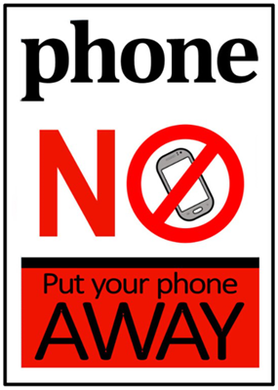
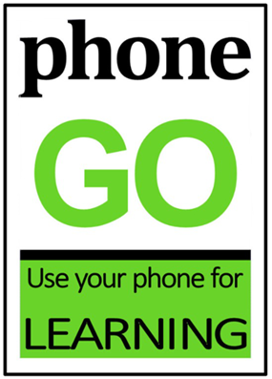

Generally, a mobile phone will be used inappropriately if it:
- does not comply with the school’s Phone GO/ NO system
- disrupts a student’s own learning, the class or is likely to disrupt the learning environment or interfere with the operation of the school
- is taken into an assessment task or examination situation
- threatens or is likely to threaten the safety or wellbeing of any person
- is in breach of any law, in particular the Australian Telecommunications Act 1997.

Inappropriate use of mobile phones includes students using them to bully, intimidate or otherwise harass other people through any SMS or text message, photographic, video or other data transfer system available on the phone.

Note: the use of ear buds/ ear pods/ headphones will not be deemed as acceptable except under Risk/ Behaviour Management plan or Student Behaviour Support Plan direction.
Summary of Responsibilities
Note: The school takes no responsibility for loss of or damage to mobile phones, except for those in its care.

Students will: | Parents/ Carers will: | Staff will: | CHS Executive will:
- Follow the direction of the Phone GO/ NO system  - Use mobile phones appropriately in classes as and when directed by the teacher via the Phone GO sign  - Have phone off and away when directed by the NO Phone sign  - Not use earbuds, ear pods or headphones in class.  - Not arrange to leave the school via mobile phones  - Comply with staff direction related to mobile phones, including confiscation if warranted under this policy  - Refrain from taking photographs or video of people without their permission or harass and intimidate others – relevant laws will be adhered to. | - Support the school in the implementation of this policy  - Encourage students to comply with all aspects of this policy and talk to their child about expectations related to appropriate phone use  - Arrange for students to leave the school or of an emergency via the school office (ph. 68952333)  - Refrain from contacting students on their phone during class times | - Clearly indicate when phones may be used as part of a lesson using the Phone GO/ No signs  - Issue a verbal warning for student to put phone away if a student does not comply with the Phone GO/ NO system  - Confiscate the phone for the duration of the lesson and record as a confiscation via Sentral if a student fails to comply after a warning  - Seek Head Teacher support if a student fails to comply with confiscation | - Support and work collaboratively with all members of the school community in regards the implementation of this policy  - Implement appropriate consequences for non-compliance with any aspect of this policy (e.g. revocation of phone privilege, Suspension Warning Notification, Suspension)  - Establish notification processes via Sentral for repeated non-compliance with any aspect of this policy

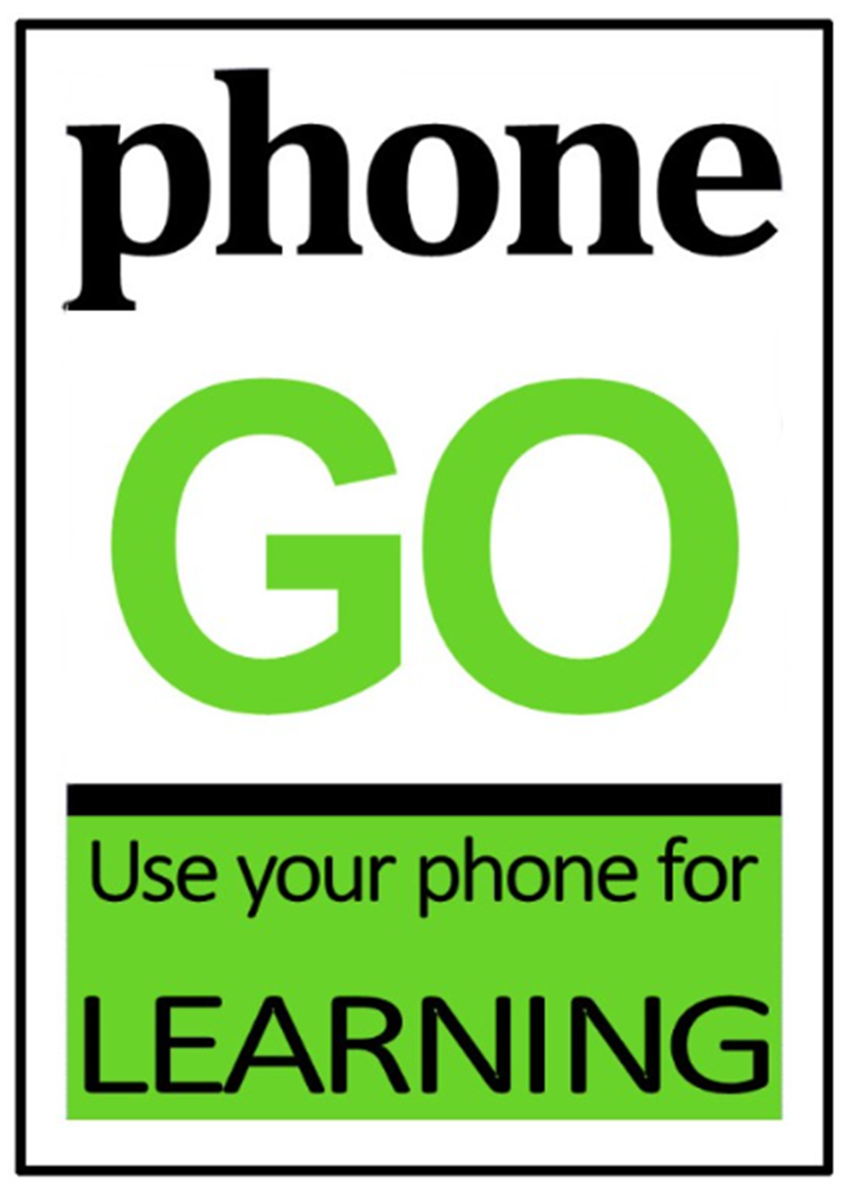
PLEASE NOTE: EARBUDS/ AIRPODS AND THE LIKE ARE NOT PERMITTED.
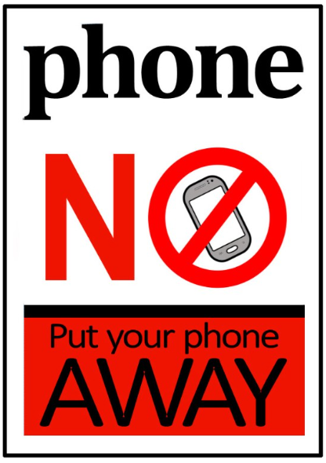
PLEASE NOTE: EARBUDS/ AIRPODS AND THE LIKE ARE NOT PERMITTED

